**DAILY ONLINE ACTIVITIES SUMMARY**

|  |  |  |  |  |  |  |  |  |
| --- | --- | --- | --- | --- | --- | --- | --- | --- |
| **Date:** | 05-06-2020 | | | | | **Name:** | D Richard Franklin | |
| **Sem & Sec** | Fourth sem section A | | | | | **USN:** | 4AL18CS020 | |
| **Online Test Summary** | | | | | | | | |
| **Subject** | | N/A | | | | | | |
| **Max. Marks** | | N/A | | **Score** | | | N/A | |
| **Certification Course Summary** | | | | | | | | |
| **Course** | 1. [Data Visualization using Tableau](https://olympus.greatlearning.in/courses/10918) | | | | | | | |
| **Certificate Provider** | | | greatlearning | | **Duration** | | | **3 hr** |
| **Coding Challenges** | | | | | | | | |
| **Problem Statement:**  1: Program to find how many of the input numbers can be written as powers of 2  2: You are given an array of n numbers and q queries. For each query you have to print the floor of the expected value(mean) of the subarray from L to R. | | | | | | | | |
| **Status:** completed | | | | | | | | |
| **Uploaded the report in Github** | | | | | yes | | | |
| **If yes Repository name** | | | | | <https://github.com/alvas-education-foundation/Richard_Franklin> | | | |
| **Uploaded the report in slack** | | | | | yes | | | |

**Online Test Details: N/A**

**Online Course Details:**

1. Name of course:[Data Visualization using Tableau](https://olympus.greatlearning.in/courses/10918)

Certificate provider: greatlearning

The total course was about understanding the way data can be represented and how data can be organized in a proper way. How data can be analyzed from its representation and clearly get the required information after processing.

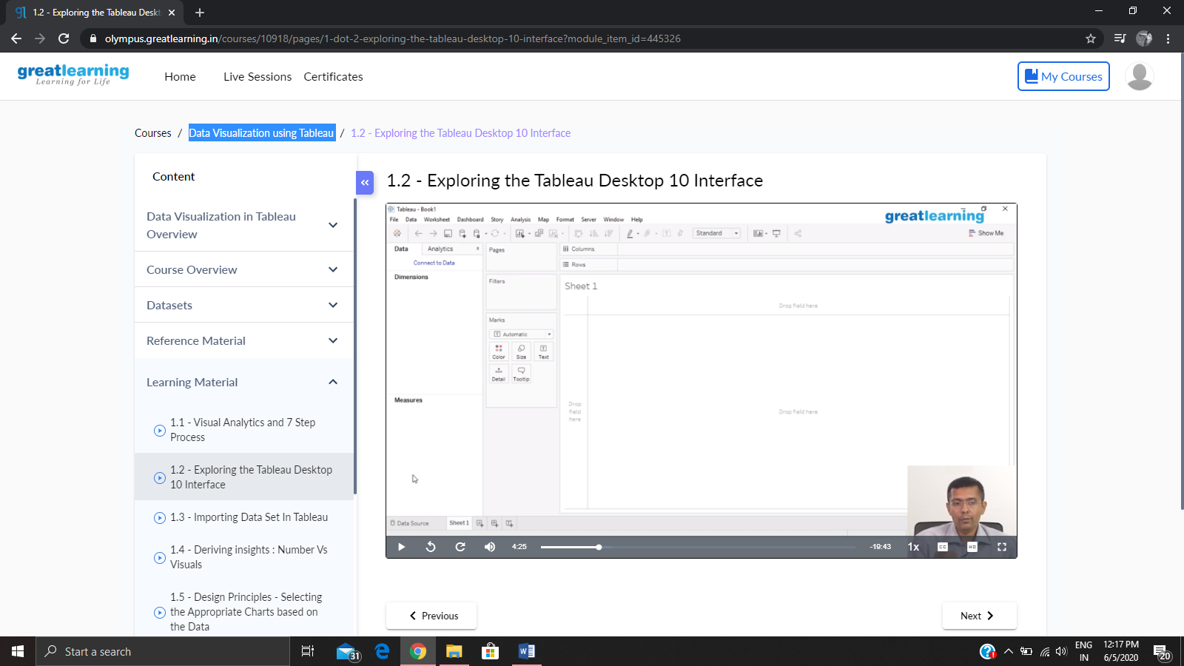

**Online coding:**

Problem 1: (using python) Program to find how many of the input numbers can be written as powers of 2

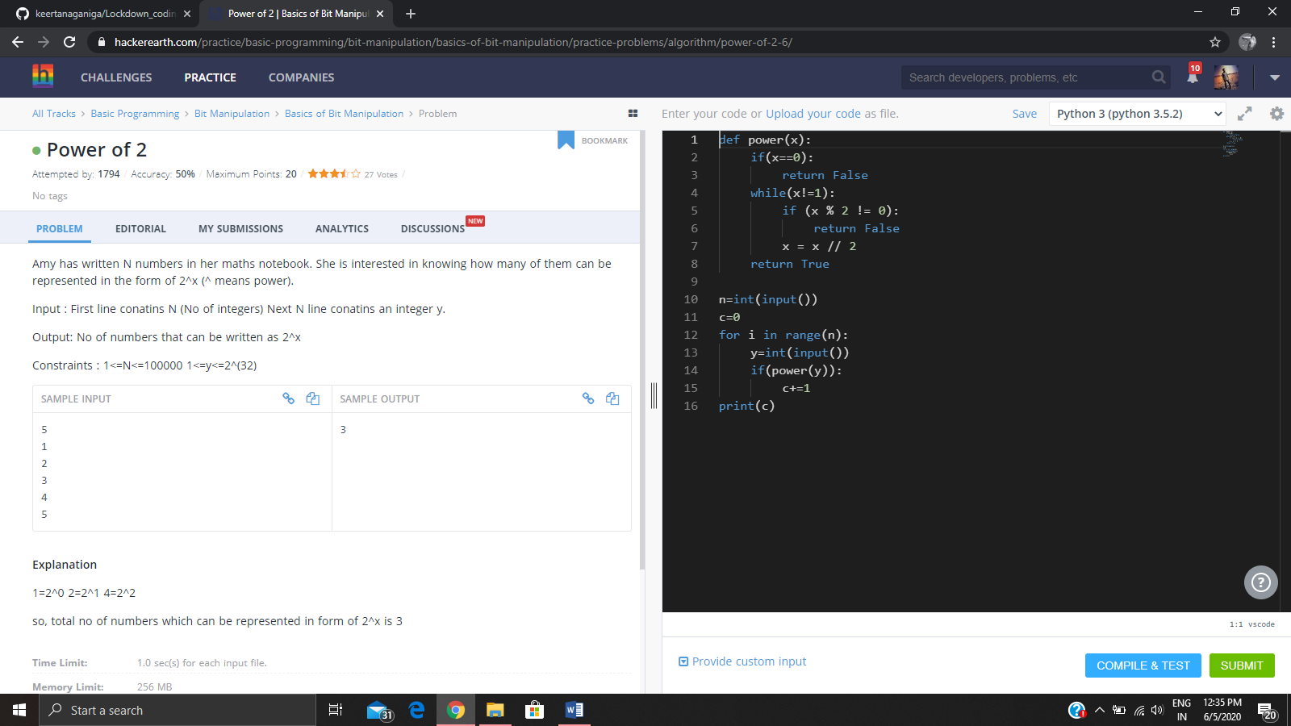.

Problem 2: (using C++) You are given an array of n numbers and q queries. For each query you have to print the floor of the expected value(mean) of the subarray from L to R.

